24-678: Computer Vision for Engineers

Ryan Wu

ID: weihuanw

PS5 Report

Due: Nov 3 2023

This file contains the following:

PS5-1 Binary image processing – detecting blobs, contours, and central axes

* wall1-blobs.png, wall2-blobs.png
* wall1-contours.png, wall2-contours.png
* wall1-crackss.png, wall2-cracks.png
* readme.txt
* source code file(s) (attached to the end)

**Findings and discussion:**

We are tasked to perform dilation, erosion, contouring, crack detection, and thinning for 2 separate wall images.

In my program, I defined 5 different functions to perform: 1. Loading the given images, 2. Perform dilation and erosion, 3. Contour drawing, 4. Crack detection 5. Thinning the detected crack. Certain parameters, like iterations, and contour length thresholds, were determined by trial and error.

In my dilation and erosions logic, the process iteration was set to 3. In my crack detection logic, I choose the contour’s length as the determining factor. For wall1 and wall2 images, the contour length threshold was set at 2000 and 500 respectively, any length that is less than their declared threshold was filtered (used <= since the image was inverted to black background before the operation).

The results were satisfactory and the program performed all the tasks stated above.

**PS5-1 wall1 & wall2 blobs images and function used**

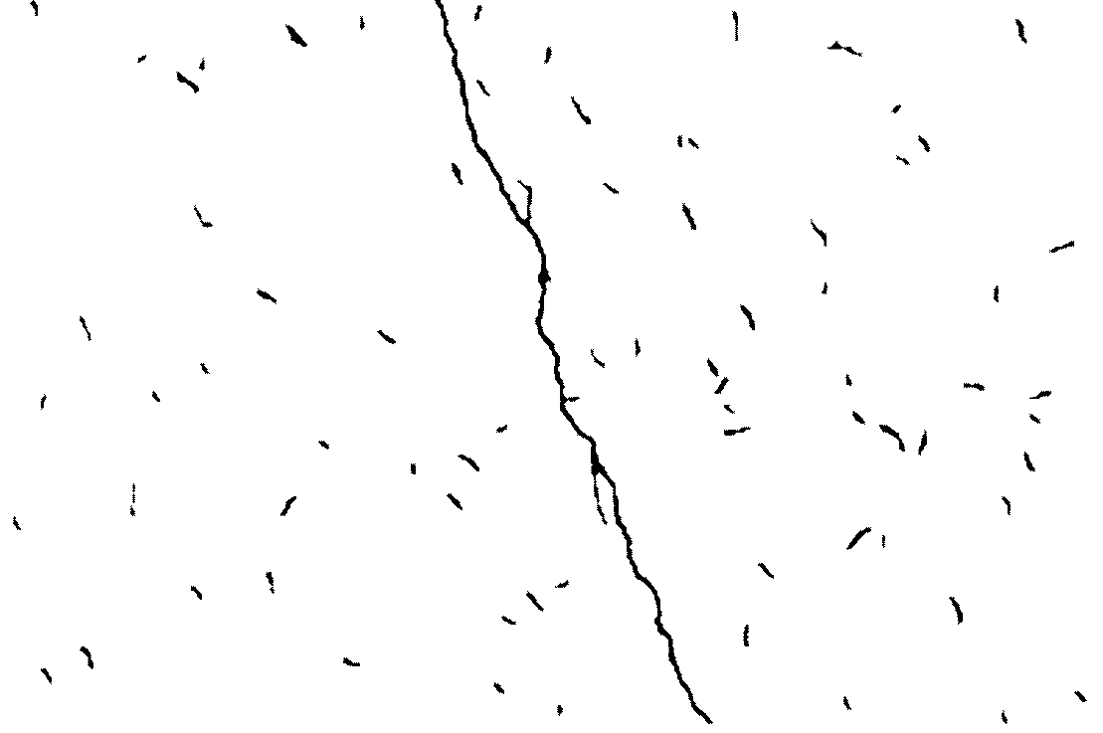

Figure . wall1 image with blobs shown.



Figure . wall2 image with blobs shown.

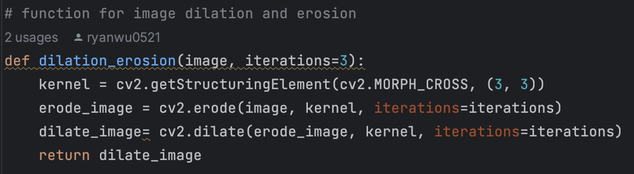

Figure . The function used for blob detection.

**PS5-1 wall1 & wall2 contours images and function used**

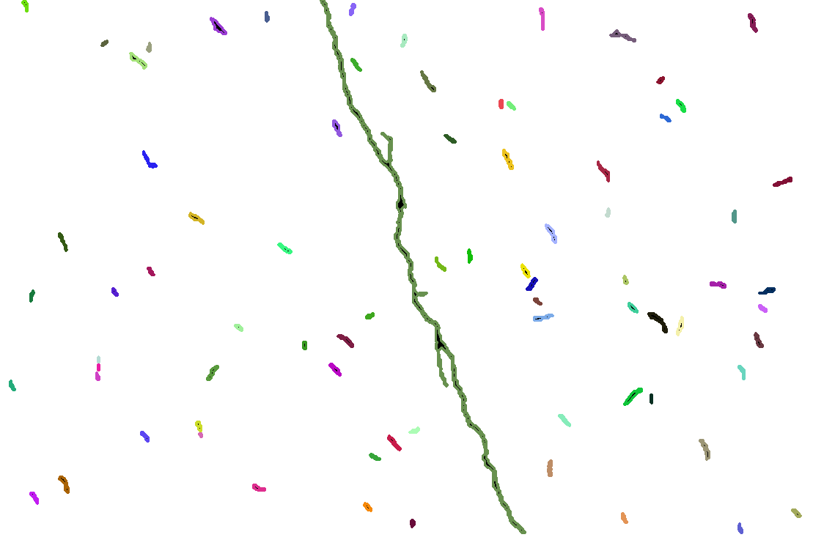

Figure . wall1 with random contours shown.

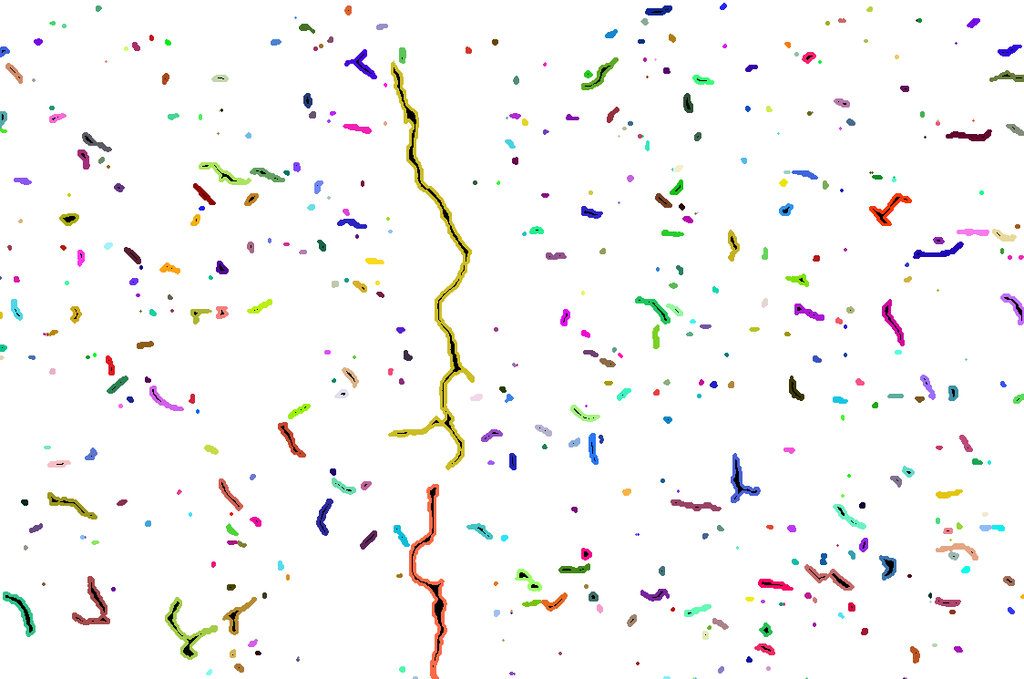

Figure . wall2 with random contours shown.

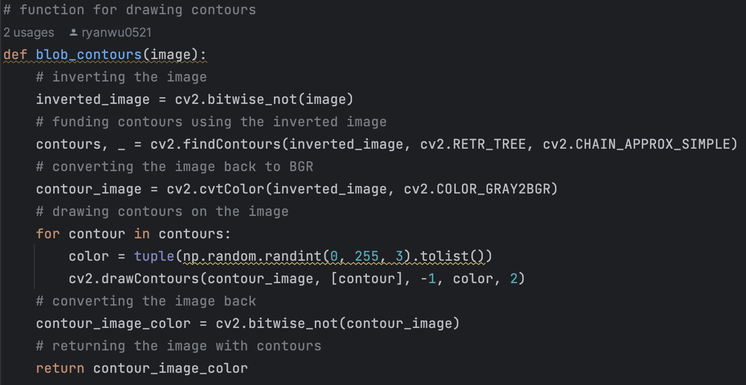

Figure .The function used for contour drawing.

**PS5-1 wall1 & wall2 cracks images**



Figure . wall1 crack image after thinning.



Figure . wall2 crack image after thinning

**PS5-1 wall1 & wall2 cracks images function used**

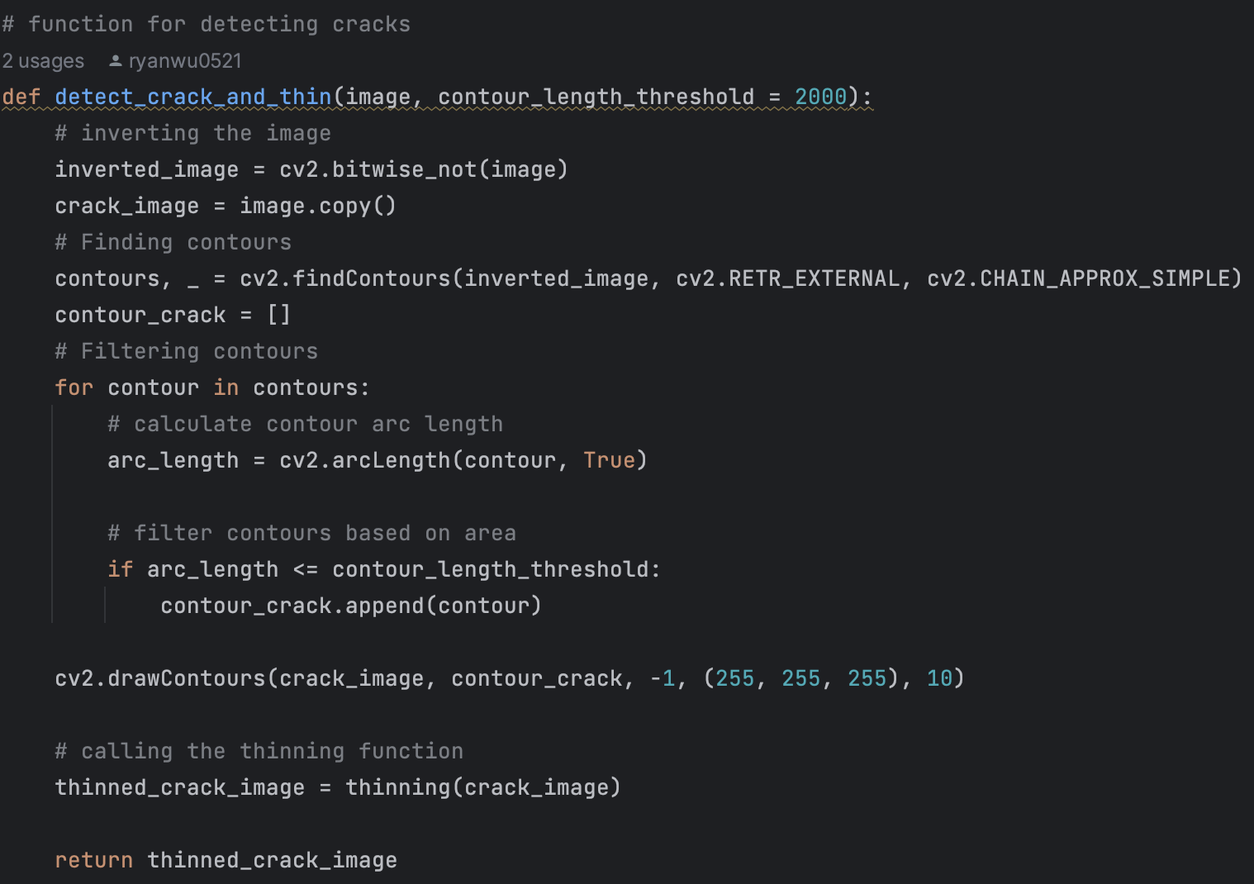

Figure . The function used for crack detection.

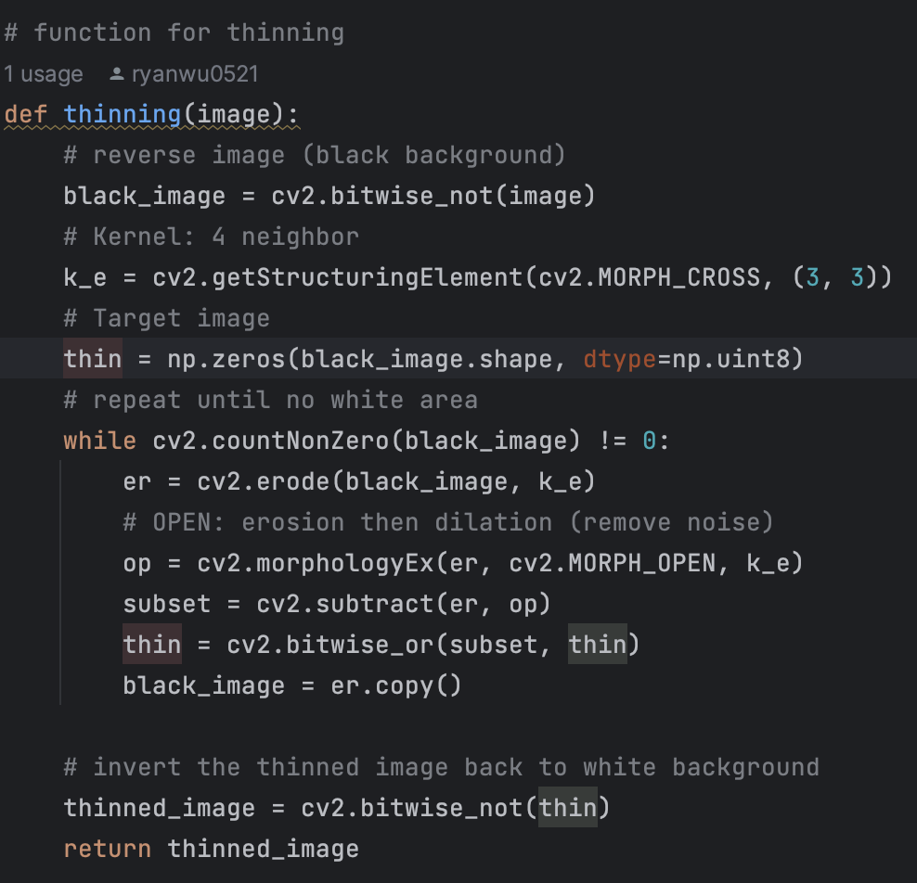

Figure . The function used for crack thinning.

**PS5-1 readme.txt**

24-678: Computer Vision for Engineers

Ryan Wu

ID: weihuanw

PS5-1 Binary image processing – detecting blobs, contours, and central axes

Operating system: macOS Ventura 13.5.2

IDE you used to write and run your code: PyCharm 2023.1.4 (Community Edition)

The number of hours you spent to finish this problem: 8 hours.